**Acharya Narendra Dev College**

University of Delhi



**Project developed for IAPT Conference (2024-25)**

**“ 4 Bit Computational code conversion calculator ”**

Submitted by : -

**Himanshu verma**

College Roll no . – 230416

BSc. Hons Electronics - 2 semester (1st year )

**Abstract**

This research project is focused on developing 4 bit’s computational code conversion calculator using gate IC’s decoder and combinational circuits

The primary objective of our project is to create, develop and design a 4 Bit’ computational core conversion calculator Which is capable of Compute , show and represent Conversions in other number system like BCD(binary coded decimal), Gray, Decimal, Hexadecimal and Octal Up 4 BIT’S which is 0 to 15 By switching 4 bit data inputs, thought this single 4 bit data input switching we will be able to represent and show codes of other number system equivalent to that binary inputs provided earlier for conversion . by the help of five different conversion units for each different code conversions provided earlier for conversion. separate conversion units can be detached and behave as single conversion unit as well. this Advance logic code conversion circuit tech design will help in Advance Arithmetics and Logic computations as we are living in the world of quantum computers

This logic circuit-tech design can be used in various types of base conversion computations, can be the conversion unit of computers and calculators with advance features thus it can be used and treated as an educational tool for better understanding of logics, number systems, separate unit can be detached and work as single conversion unit and capable to function independently in carring out one conversion.

**Certificate**

This is to certify that this project on 4 bit’s computational code conversion calculator using gate logic ic, decorder and combinational circuits Has been undertaken under the **SUMMER ELITE RESEARCH INTERNSHIP PROJECT** scheme of **ACHARYA NARENDRA DEV COLLEGE, UNIVERSITY OF DELHI** and implemented by me in research laboratory this week has not been submitted by us anywhere earlier fully

Dr. Ravneet Kaur Dr. Monika Bhattacharya

Mentor Mentor

Department of Electronics Department of Electronics

Acharya Narendra Dev College Acharya Narendra Dev College

Prof. Ravi Toteja

Principal

Acharya Narendra Dev College

**Acknowledgement**

We would like to extend our heartfelt appreciation and profound gratitude to our esteemed mentors, **Dr. Ravneet Kaur** and

**Dr. Monika Bhattacharya**, for their unwavering support and invaluable guidance throughout our journey. A special note of thanks to **Dr. Amit Garg** and **Prof. Anju Aggarwal** and all the faculty members of my department whose exemplary mentorship, diligent monitoring, and constant encouragement have been instrumental in the successful completion of our project. We also express our sincere thanks to the dedicated support staff members whose assistance played a pivotal role in making our project a resounding success. Our deepest gratitude goes to our esteemed Principal Dr. Ravi Toteja, for providing us with the invaluable opportunity to embark on this meaningful project. Their blessings and unwavering support will undoubtedly propel us further in the journey of life. Lastly, a big thanks to all for the invaluable contributions to this research project.

**Contents**

**1. INTRODUCTION**

1.1 Overview

1.2 Objective

1.3 Circuit Design

**2. HARDWARE AND SOFTWARE REQUIREMENTS**

2.1 Materials and Components Required

2.2 Description of Hardware components

**3. Computational conversion circuit**

3.1 conversion circuit

3.2 data processing and minimization of circuit design

**4. Implementation of Computational Codes in the 4-bit Computational code conversion calculator**

4.1. Attachment of conversion unit of calculator

4.2. Attachment of conversion unit to the data bus

**5. Applications and Future work**

5.1 application

5.2 Future scope

1. **INTRODUCTION**

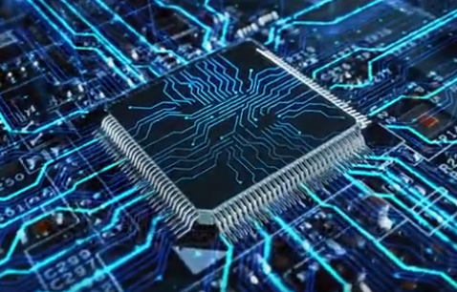Welcome to the world of digital electronics and computational conversions! Our research project focuses on designing a 4-bit computational code conversion calculator. As technology advances, efficient data representation and conversion between different number systems are becoming increasingly essential. Our project aims to develop a reliable and effective calculator capable of converting 4-bit binary inputs into BCD, Decimal, Hexadecimal, and Octal formats using gate ICs, decoders, and combinational circuits. This project will aid in understanding and applying various number systems in Research, educational and practical contexts

**1.1 Overview**

In digital electronics and computing, converting numbers between different systems is essential for various applications. Common number systems include Binary Coded Decimal (BCD), Decimal, Hexadecimal, and Octal. Efficient conversion between these systems is crucial for data processing and computation tasks.

This project focuses on developing a 4-bit computational code conversion calculator capable of converting a 4-bit binary input (ranging from 0 to 15) into BCD, Decimal, Hexadecimal, and Octal formats. The design utilizes gate ICs, decoders, and combinational circuits to perform the conversions. The device will also feature a display to show the converted values and a user interface for selecting the desired conversion. This project aims to enhance understanding and application of number systems in both educational and practical contexts.

**1.2 Objective**

The primary objective of this research project is to create a 4-bit computational code conversion calculator capable of converting binary inputs into various number systems. Specifically, we aim to achieve the following goals:

1. **Design and Implement Conversion Circuits:** Develop and integrate circuits for converting 4-bit binary inputs into BCD, Decimal, Hexadecimal, and Octal formats.
2. **Ensure Modular Functionality:** Design the conversion units to function both as an integrated system and as detachable units capable of performing individual conversions.
3. **Ensure Modular Functionality:** Design the conversion units to function both as an integrated system and as detachable units capable of performing individual conversions.

**1.3 Circuit Design**

**Software implemented circuit**

**for understanding abstract**

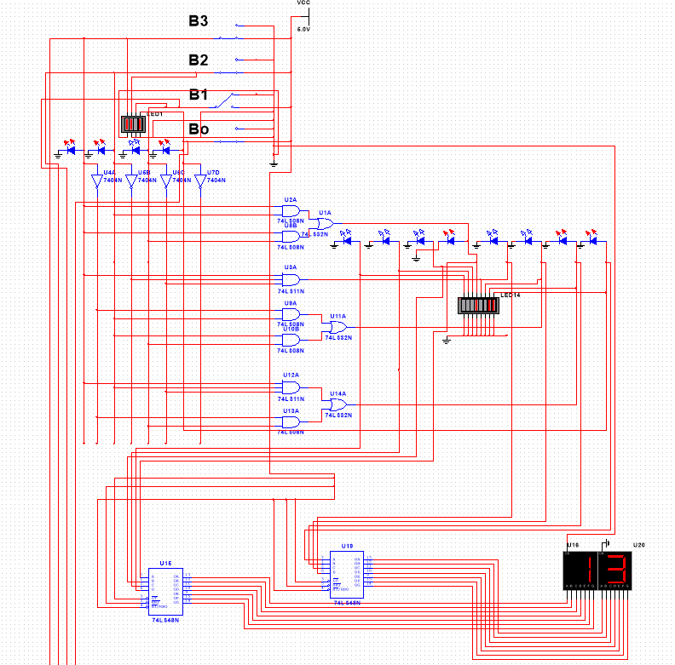

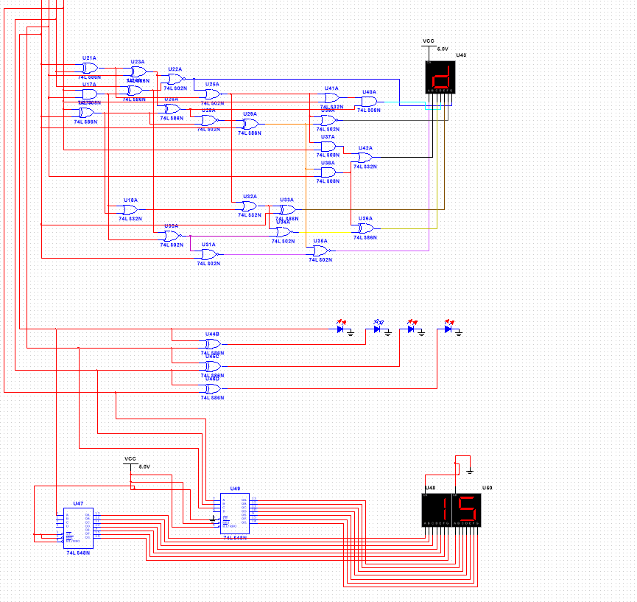

1. **Hardware and software requirement’s**

**2.1 Materials and Components**

1. Seven segment cathode and anode display’s

2. Dip switched for 4 bit’s data line.

3. Jumper Wires M-F, F-F, M-M. (for pin configuration)

4. LEDS for 1 and 0 for i’e for on and off data line.

5. Switches for controlling 4 bit’s data line.

6. 5 Volt Power supply

7. logic Gate IC’s

8. other logic IC’s for making combinational circuit for BCD, Hexa, Octal, and Decimal.

9. Multisim software for testing and troubleshooting circuit design

* 1. **Description of Hardware Components**
     1. **Logic gate IC’s**

Logic ICs (Integrated Circuits) are fundamental components in digital electronics that implement various logical functions and operations. They are used to process and control binary signals (0s and 1s) and are essential in the design of digital systems. Here are some key points about logic ICs:

1. **Types of Logic ICs:**
   * 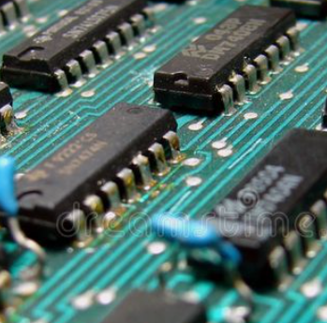**Basic Logic Gates:** Include AND, OR, NOT, NAND, NOR, XOR, and XNOR gates. These gates perform basic logical operations.
   * **Combinational Logic ICs:** These ICs perform operations based on the combination of their current inputs. Examples include multiplexers, demultiplexers, encoders, decoders, and arithmetic circuits like adders.
   * 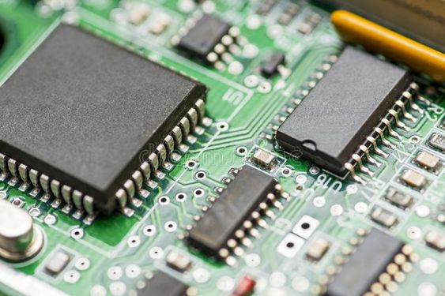**Sequential Logic ICs:** These ICs have memory elements and their output depends on both current inputs and past states. Examples include flip-flops, counters, and shift registers.
2. **Computational Conversion Circuit**

* **3.1 Conversion Circuit**
  + The conversion circuit forms the backbone of the calculator. It consists of various logic gates and ICs configured to perform specific code conversions. The circuit design includes an input stage where the 4-bit data is fed into the system. Each conversion unit is equipped with combinational logic tailored to convert the binary input into the desired output format, such as BCD, Gray, Decimal, Hexadecimal, or Octal.
  + The design ensures that the conversion process is efficient, with minimal propagation delay and optimal use of gate resources. Each unit functions in sync with the others, allowing the user to select the desired conversion through a switching mechanism.
* **3.2 Data Processing and Minimization of Circuit Design**
  + The circuit is designed with a focus on minimizing complexity while maximizing efficiency. This involves reducing the number of logic gates and ICs required to perform each conversion, without compromising accuracy. Techniques such as Karnaugh mapping (K-map) are employed to simplify Boolean expressions, leading to a more streamlined circuit.
  + Additionally, the design considers power consumption and heat dissipation, ensuring that the circuit operates within safe parameters even under prolonged use. The minimized circuit design also facilitates easier integration into larger systems or educational tools.

1. **Implementation of Computational Codes in the 4-bit Computational Code Conversion Calculator**

**4.1 Attachment of Conversion Unit of Calculator**

* + Each conversion unit is modular, meaning it can be detached and reattached as needed. This modularity allows for easy maintenance and upgrades. The units are connected through standardized interfaces, ensuring that they can work together seamlessly when combined into the full calculator system.
  + The attachment process involves aligning the input and output ports of each unit to ensure proper data flow. Once connected, the units operate as a cohesive system, converting the 4-bit input into the selected output format based on user input.

**4.2 Attachment of Conversion Unit to the Data Bus**

* + The conversion units are connected to a central data bus, which serves as the communication backbone for the system. The data bus transmits the 4-bit input to the selected conversion unit and retrieves the converted output for display.
  + The design ensures that data transfer within the bus is synchronized, with minimal interference or data loss. Each unit is equipped with buffers to handle data efficiently, allowing for smooth operation even when multiple conversions are performed in rapid succession.

1. **Applications and Future Work**

**5.1 Application**

The developed calculator has a wide range of applications, from educational tools to advanced computational systems. It can be used to teach students about different number systems and their conversions, providing a hands-on learning experience.

**5.2 Future work**

In the future, the design can be expanded to include more number systems or even different types of computations, such as arithmetic operations or logic functions. The modular nature of the design allows for easy scalability, making it adaptable to new technologies and computational requirements.